**Work plan and POC definition**

**VisiFood – 609**

**Nir Abadi**

**Asaf Weitzman**

**Yaniv Meshullam**

**Guy Kayam**

**Maayan Ohana Bashary**

**Databases**

**Stickers database**

So far we have collected about 600 pictures of products that include stickers of **high sugar/sodium/saturated fat** count or the **green label** indicating it's a healthy product.

The pictures are currently in different resolutions.

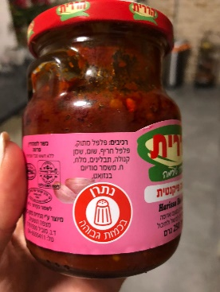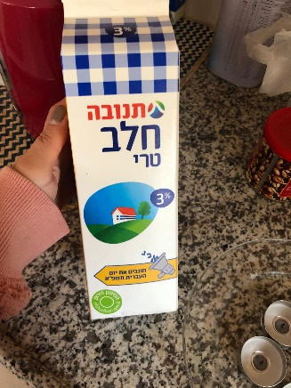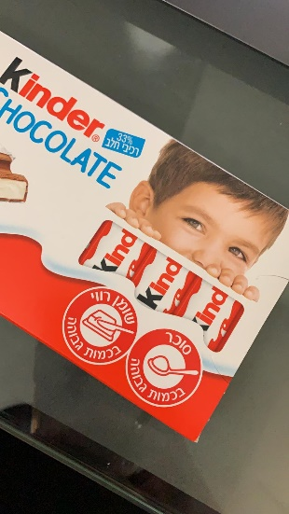

**Expiration dates database**

So far we have collected about 1,100 pictures of products that include expiration dates in different patterns.

The pictures are currently in different resolutions.

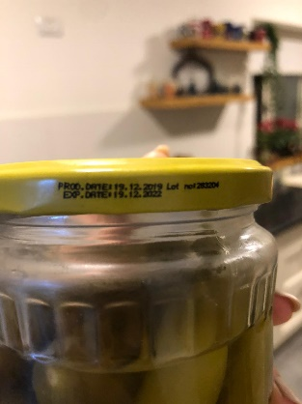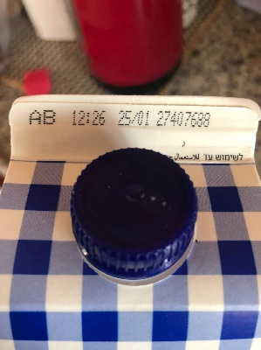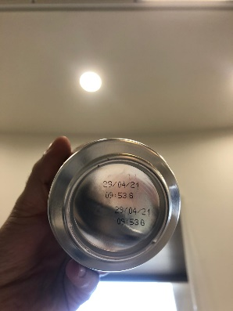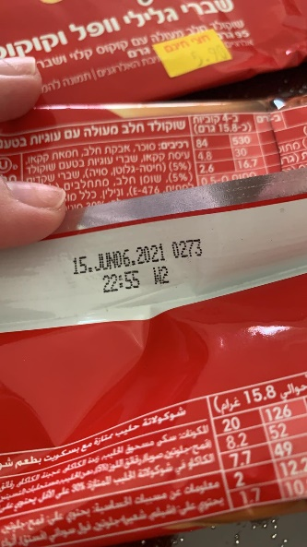

**Fruits database**

This database can be found on **Kaggle** at <https://www.kaggle.com/chrisfilo/fruit-recognition> and at <https://www.kaggle.com/moltean/fruits>.

Fruits-360 Dataset properties

*Total number of images:* 90483.*Training set size:* 67692 images (one fruit or vegetable per image).*Test set size:* 22688 images (one fruit or vegetable per image).*Multi-fruits set size:* 103 images (more than one fruit (or fruit class) per image).*Number of classes:* 131 (fruits and vegetables).*Image size:* 100x100 pixels.

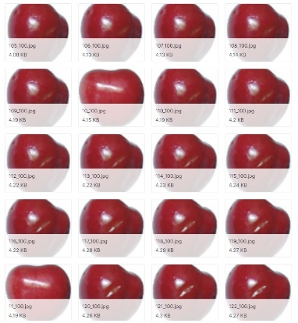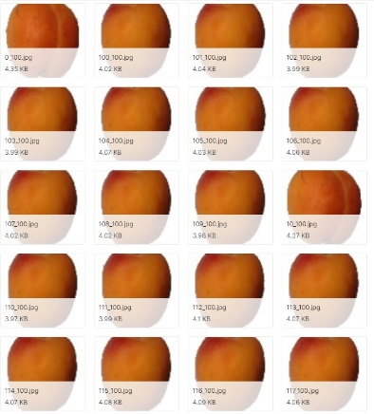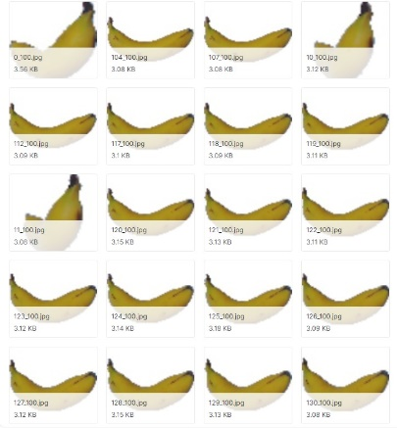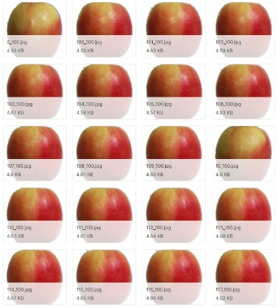*Filename format:* imageindex100.jpg (e.g. 32100.jpg) or rimageindex100.jpg (e.g. r32100.jpg) or r2imageindex100.jpg or r3imageindex100.jpg. "r" stands for rotated fruit. "r2" means that the fruit was rotated around the 3rd axis. "100" comes from image size (100x100 pixels).Different varieties of the same fruit (apple for instance) are stored as belonging to different classes.

Fruit recognition Dataset properties

The database used in this study is comprising of 44406 fruit images, which we collected in a period of 6 months. The images where made with in our lab’s environment under different scenarios which we mention below. We captured all the images on a clear background with resolution of 320×258 pixels. We used HD Logitech web camera to took the pictures. During collecting this database, we created all kind of challenges, which, we have to face in real-world recognition scenarios in supermarket and fruit shops such as light, shadow, sunshine, pose variation, to make our model robust for, it might be necessary to cope with illumination variation, camera capturing artifacts, specular reflection shading and shadows. We tested our model’s robustness in all scenarios and it perform quit well.

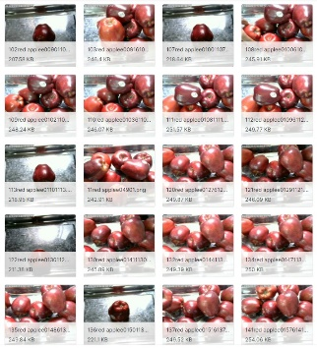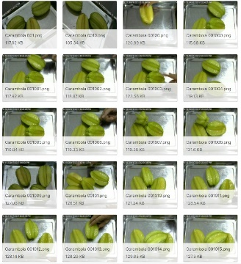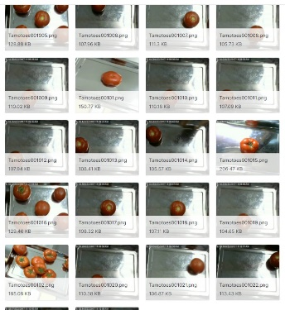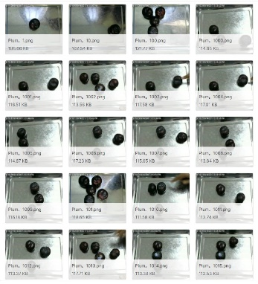

Note: We need to understand if the database is relevant to our needs.

**Work plan**

Our work plan will be executed by the following milestones:

**Milestone 1 – End of January**

Gather a large enough amount of pictures for our database and matching the images' resolution to our standard in case it's needed.

**Milestone 2 – End of February**

Develop 3 algorithms, each of which will focus on a different aspect of the project.

**Milestone 3 – End of March**

3.1. Train the neural networks with the algorithms mentioned above.

3.2. Test the networks’ functionality and correct any mistakes found.

**Milestone 4 – 15th of May**

Develop the application focusing on accessibility for the visually impaired.

4.1. Client-side – Basic GUI able to be used by the user – Nir, Maayan.

4.2. Server-side – Implementing the neural networks in the application – Yaniv, Guy, Asaf.

At first, all team members will work together on the same tasks, gradually splitting to focus on different areas in the project.

|  |  |  |  |  |
| --- | --- | --- | --- | --- |
| **2021** | | | | |
| **January** | **February** | **March** | **April** | **May** |
| Milestone 1 | Milestone 2 | Milestone 3 | Milestone 4 | |

**Mockup**

